THE DRAWING(S) AND THE INFORMATION CONTAINED HEREIN ARE THE PROPERTY OF WOOJIN INDUSTRIAL SYSTEMS CO., LTD. THEY SHALL NOT BE DISCLOSED, REPRODUCED OR USED, IN ANY MANNER WITHOUT THE PRIOR WRITTEN CONSENT OF WOOJIN INDUSTRIAL SYSTEMS CO., LTD. |  | DPO 동작 절차
DISTRIBUTION |  | R  E  V  I  S  I  O  N
 |  | R  E  V  I  S  I  O  N | 0 | Jan. 6, 2012 |  | First Issued |  |  | D.B. LEE | D.S. JANG | B.J. JONE | E.K. LEE
 |  | R  E  V  I  S  I  O  N | No. | ISSUED  DATE |  | REVISION NOTE |  |  | DESIGNED | CHECKED | APPROVED | REVIEWED
 |  |  |  |  |  |  |  |  | ENGINEERING |  |  | PM
 |  | PM |  |  | REVIEWED |  | E.K. LEE |  | CUSTOMER :
 |  | ENGINEERING |  |  | APPROVED |  | B.J. JONE |  | HYUNDAI ROTEM COMPANY
 |  |  |  |  | CHECKED |  | D.S. JANG
 |  |  |  |  | DESIGNED |  | D.B. LEE |  | PROJECT :
 |  | ISSUED DATE |  |  | January 6, 2012 |  |  |  | DENVER RTD EAGLE P3  COMMUNICATION SYSTEM
 |  | ISSUED BY |  |  | R & D CENTER
 |  | PROJECT NO. |  |  | P2011-020
 |  | ORDER NO. |  |  | P110701149 |  |  |  | 
 |  | DOCUMENT NO. |  |  |  |  |  | REVISION
 |  | ???-????-???? |  |  |  |  |  | 0
TOTAL |  |  |  |  |  |  |  | 0
REVISION RECORD
Rev. No. | PAGE | Details |  | Date
Rev. No. | PAGE | FROM | TO | Date
0 | - | First Issued |  | January 6, 2012
Table of Contents

1. Method proposal for Operator using the Gooseneck microphone with his left hand 4
1.1 Gooseneck Microphone Use Method. 5
1.2 Change method of Gooseneck Microphone Automatic Select Switch. 6
2. Operation procedure for driver to use DPO microphone 7
2.1 DPO Operation Procedure. 8
2.2 Change Method of DPO Automatic Select Switch. 9

Method proposal for Operator using the Gooseneck microphone with his left hand

: 기관사가 왼손만을 사용 한다는 가정할 경우 운전대에 Push Button 이 설치 되어야 한다.

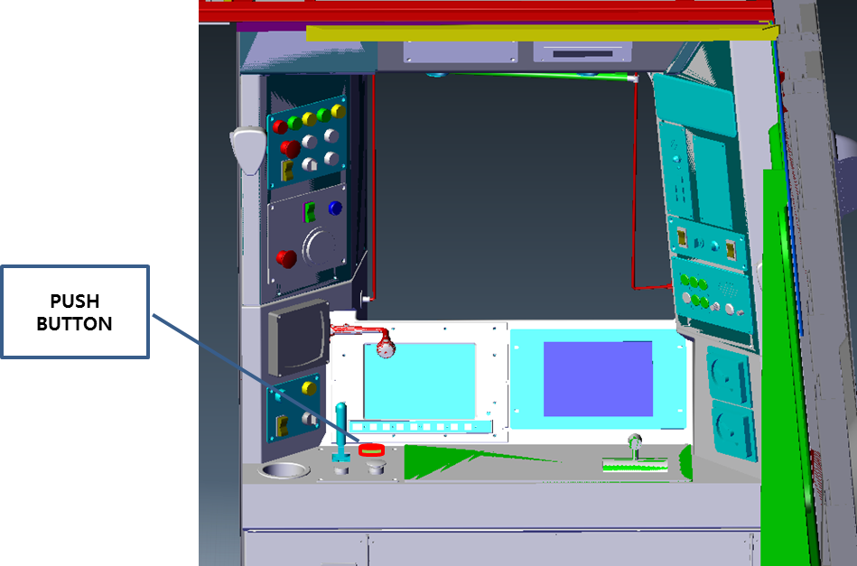

- Press PUSH BUTTON Switch with left hand.
- Speaker Select switch will be automatically selected. (No need to select switch)
- Speaker will output when the operator talks.

Speaker Select Criteria
- Remembers the final status of use.
- Press the Push Button switch and select the switch with right hand if trying to change the direction of the speaker output

Gooseneck Microphone Use Method.

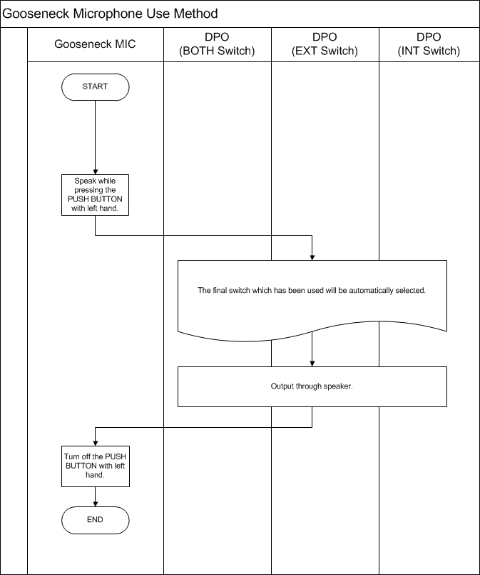

Change method of Gooseneck Microphone Automatic Select Switch.

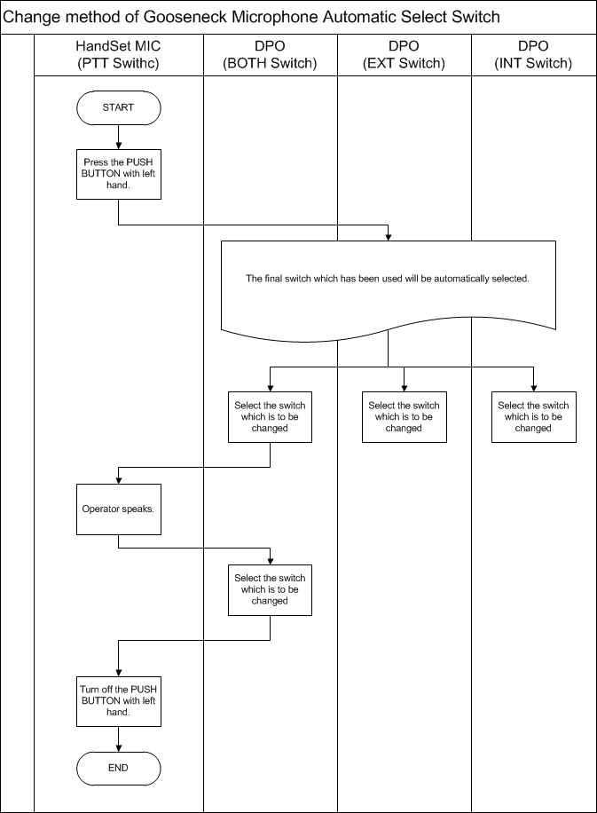

Operation procedure for driver to use DPO microphone
:기관사가 HandSet MIC를 이용하여 방송을 하는 과정을 Step – By-Step 으로 설명 하였다.

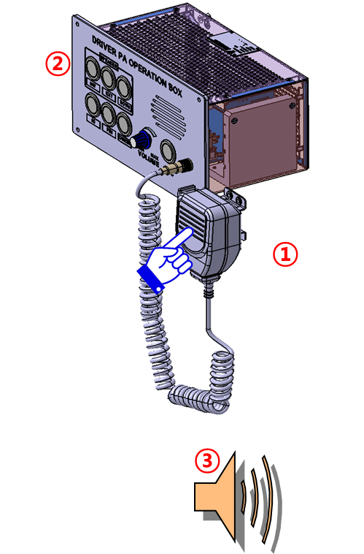

- Hold the Handset Microphone with right hand.
- Press the PTT Switch.
- Speaker Select switch will be automatically selected. (No need to select switch)
- Speaker will output when the operator talks.

Speaker Select Criteria

- Remembers the final status of use.
- Press the PTT switch and select the switch with left hand if trying to change the direction of the speaker output.

DPO Operation Procedure.

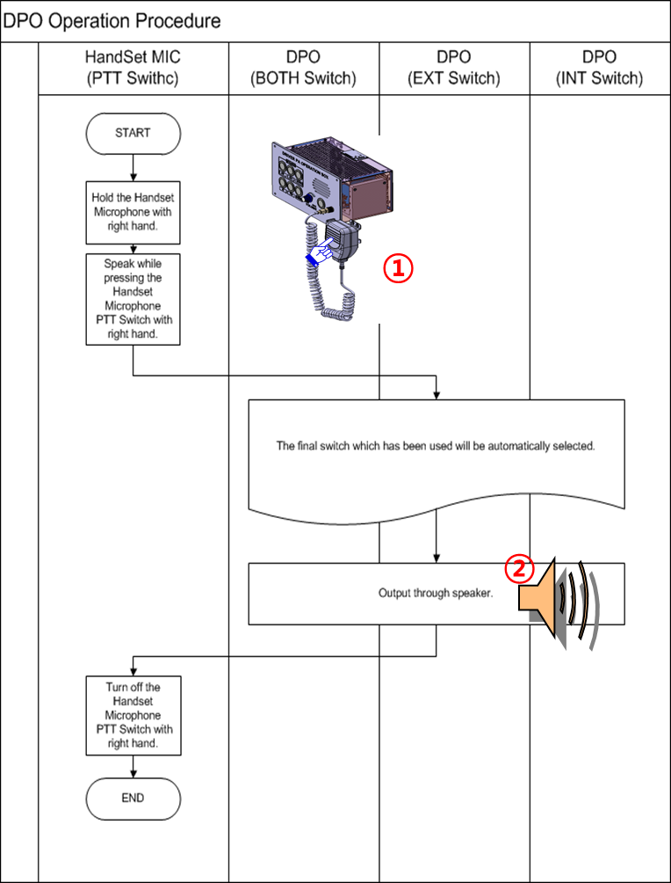

Change Method of DPO Automatic Select Switch.

